
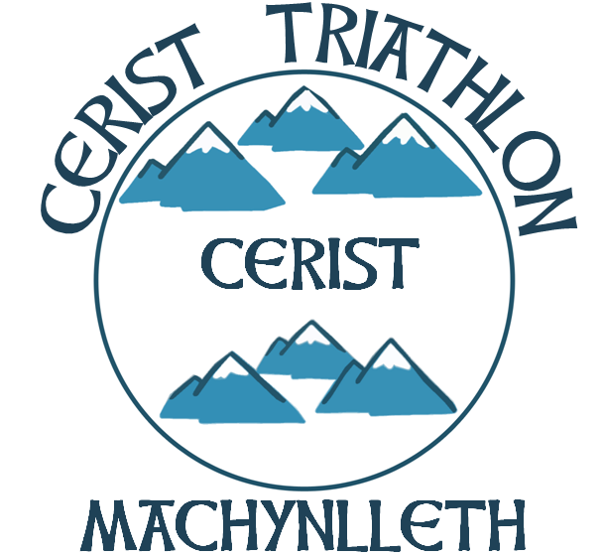
British Triathlon Volunteer Job Description

Volunteer Job Title | Welfare Officer
Type of Volunteering | To act as Welfare Officer for a club.
Main Purpose of Volunteering | To be responsible for the implementation of good practice and child protection policies within the club.
Responsible to | The Chairperson of the club.
Competencies / Experience required | Must be well-organised, have good listening skills and have the ability to deal appropriately with problems if and when they arise.
Commitment required | Maximum of 9 x 2 hour meetings a year plus responsibility of dealing with any issues that arise.
Benefits to self | Gain knowledge on Child Protection and good practice within clubs and contribute to the improvement of your club and/or region in these areas.
Benefits to community | Safer clubs who are aware of current examples of good practice and understand child protection issues.
Support received from: | The clubs’ Chair and the Regional Development Officer. Training will also be provided to help the person fulfil the role.
Is this Volunteer Opportunity open to disabled persons? | Yes.

